**Active Directory**

Open **Directory Service** in AWS

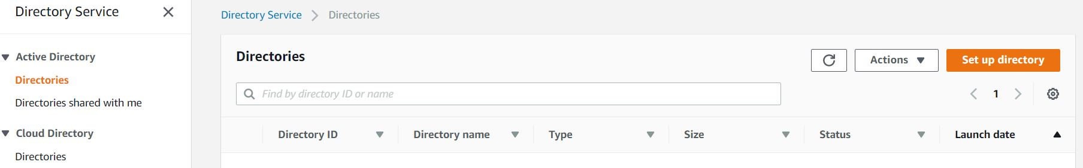

Click on **Set up directory**

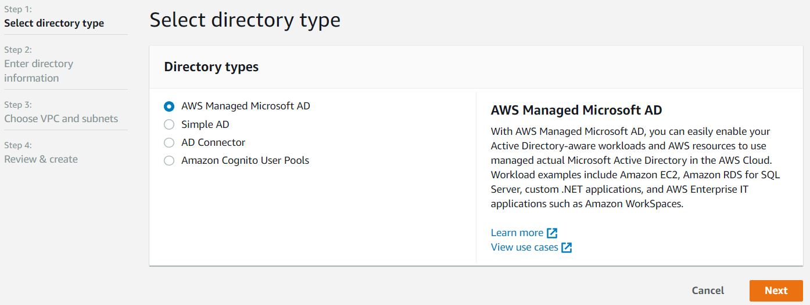

Select **AWS Managed Microsoft AD** and then click on **Next**

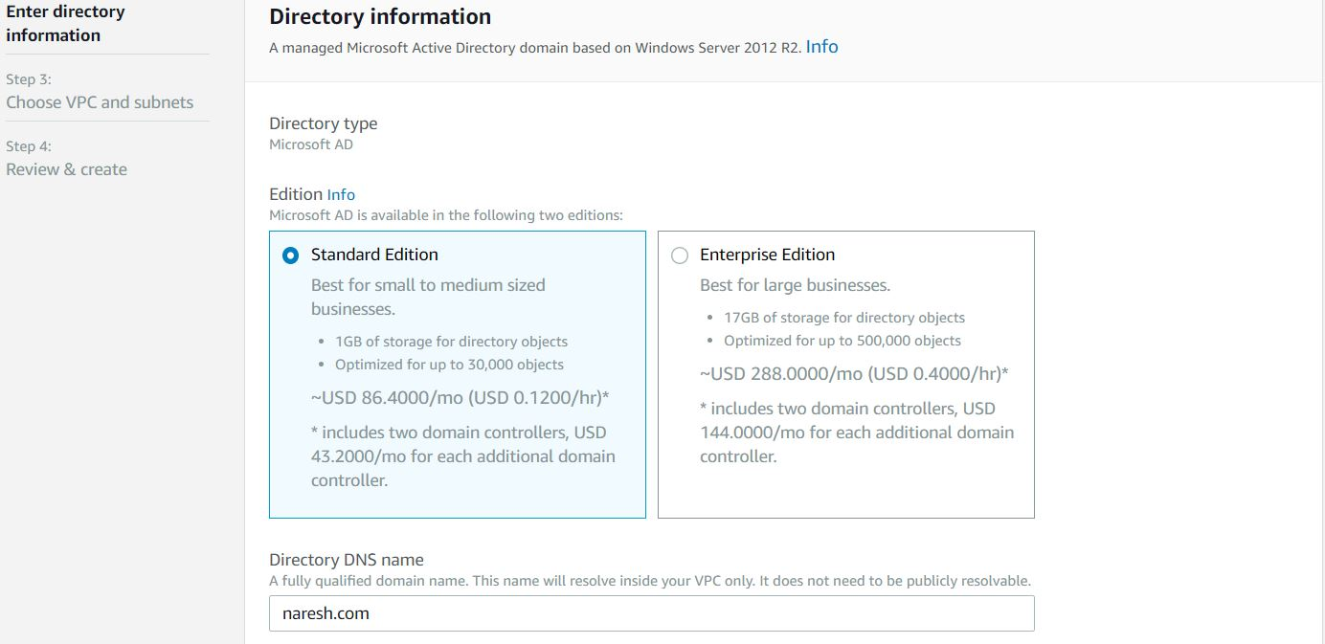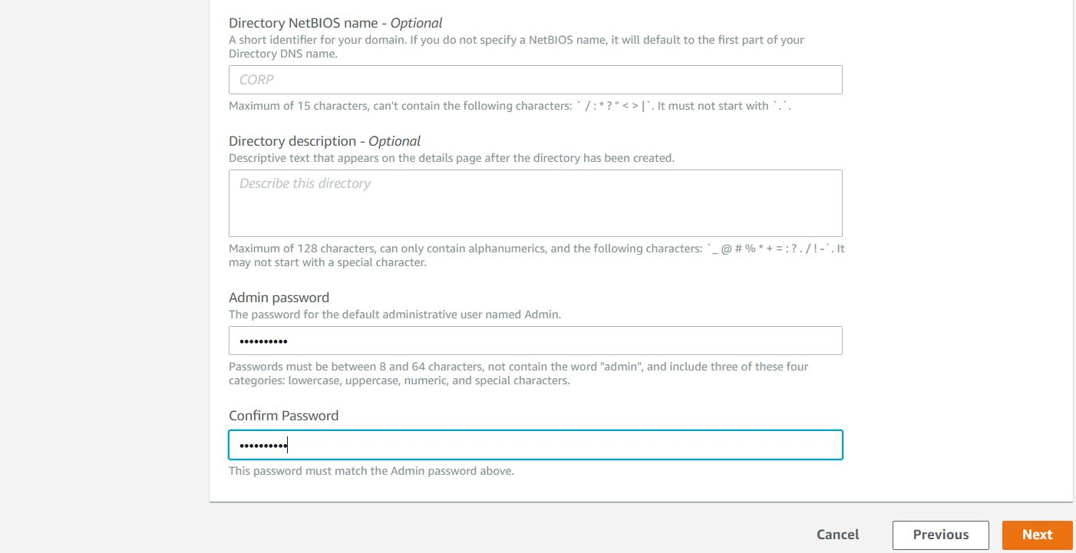

Give Details for Directory DNS Name and password

Click on Next

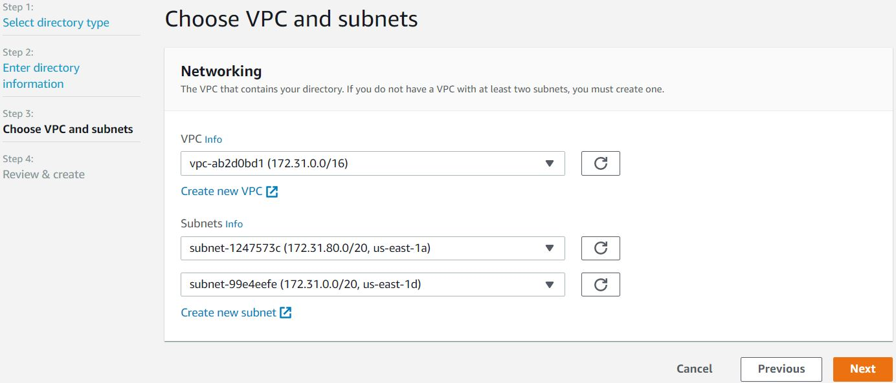

Give VPC and Subnet details and then Click on **Next**

Review details and Click on **Create directory**

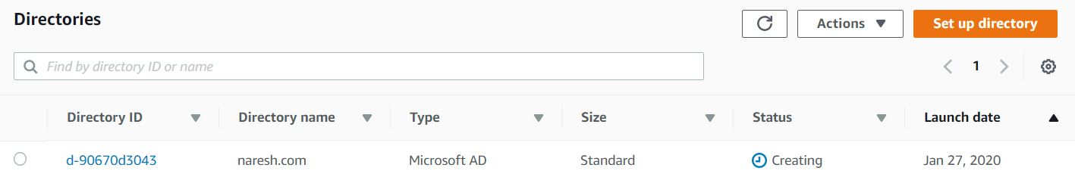

Please wait until status comes to **Active**

Check Directory status comes to **Active**

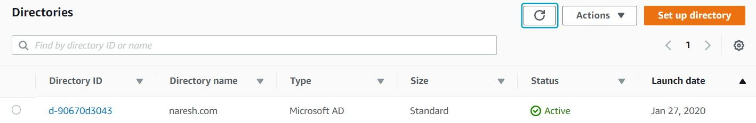

Directory Details are shown below

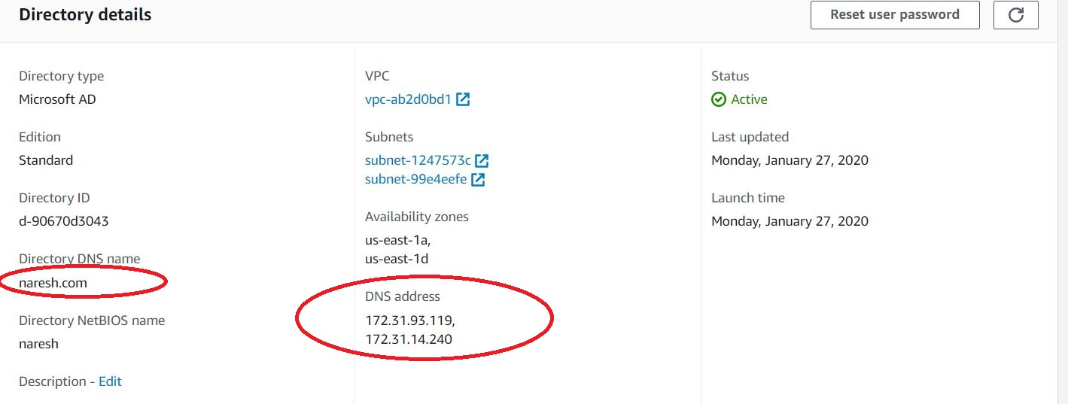

Go to EC2 and create Instance



Click on **Launch instance**

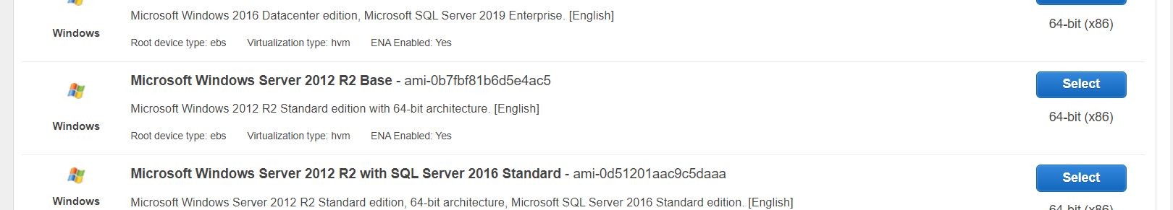

Select Amazon Machine Image as **Windows Server 2012 R2 Base**

Select security details as below

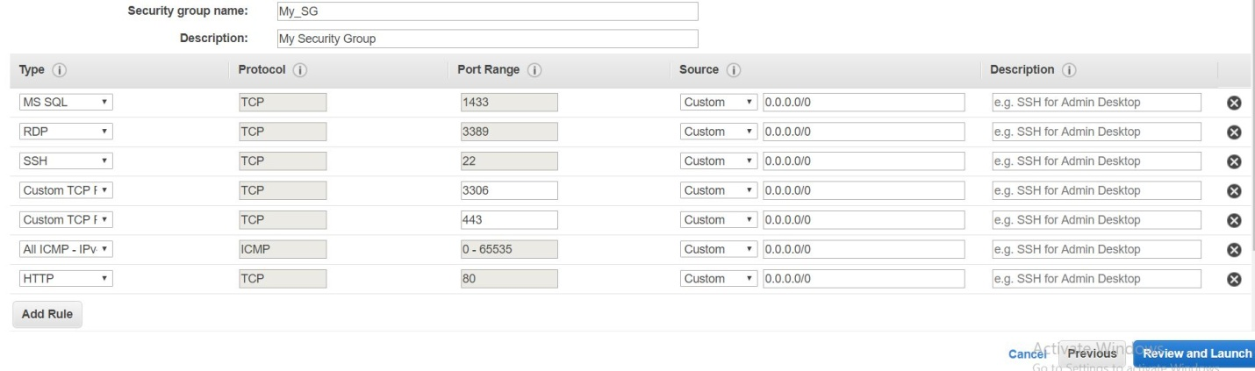

Click on Review and Launch

Click on Launch

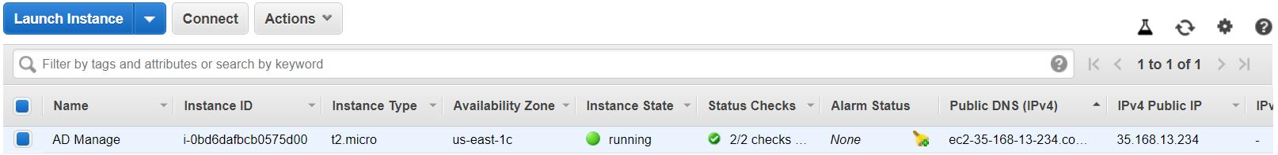

Click on connect

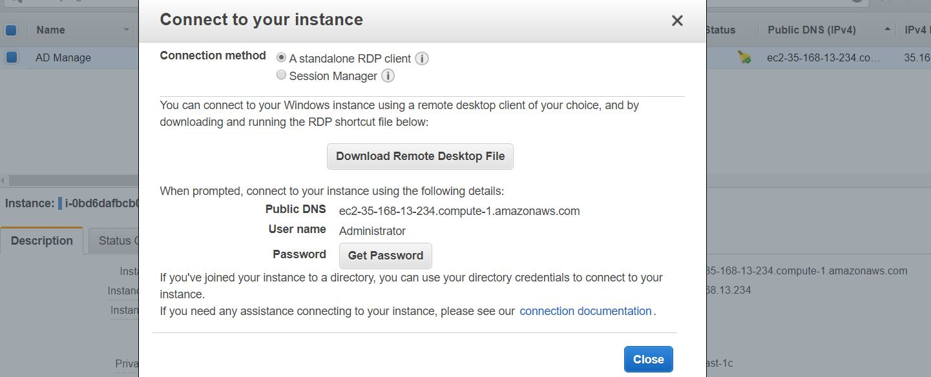

Click on Get Password

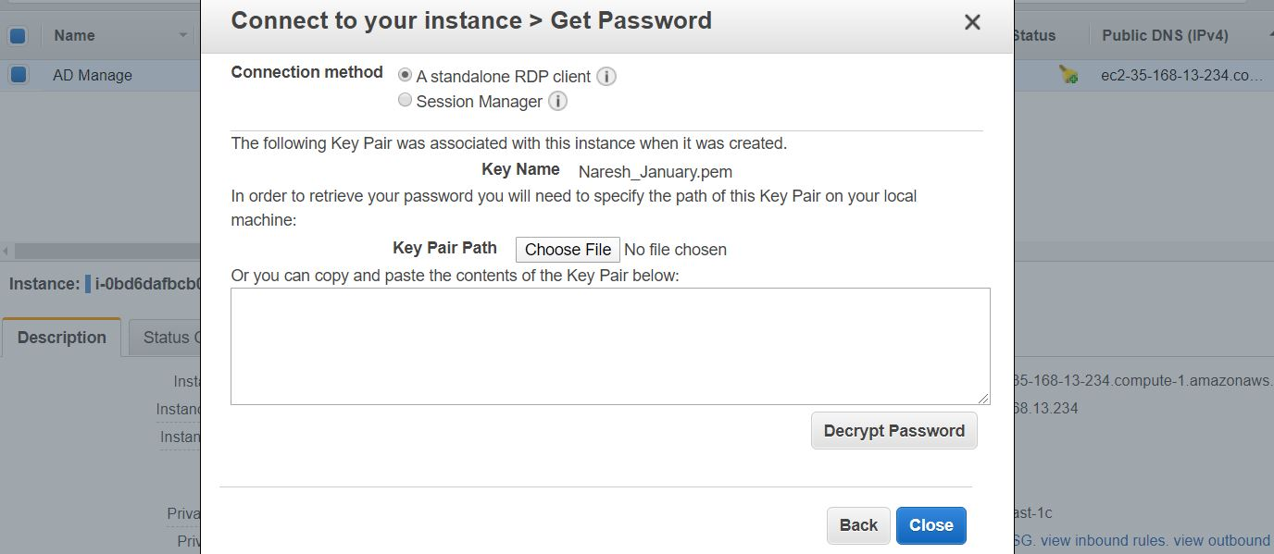

Choose Key file and click on **Decrypt Password**

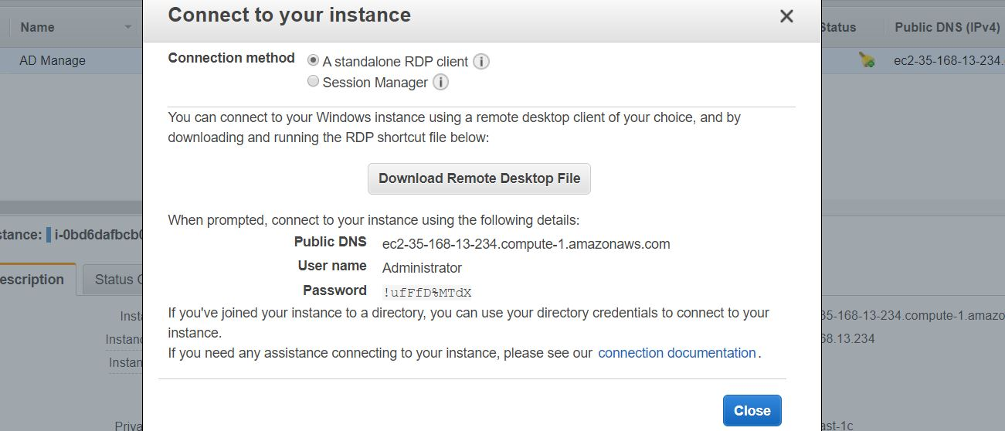

Click on Download Remote Desktop File

One file will be downloaded and run the that file

Click on connect and give password which we get above image

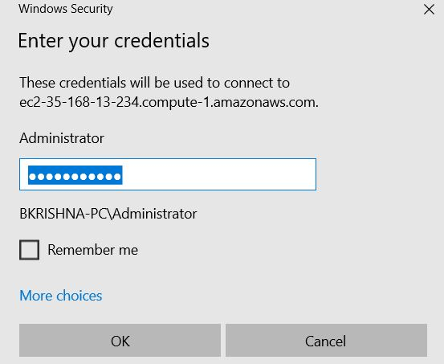

Click on OK

We get our work space

Now open Work Space

Goto control panel 🡪select view as small icons

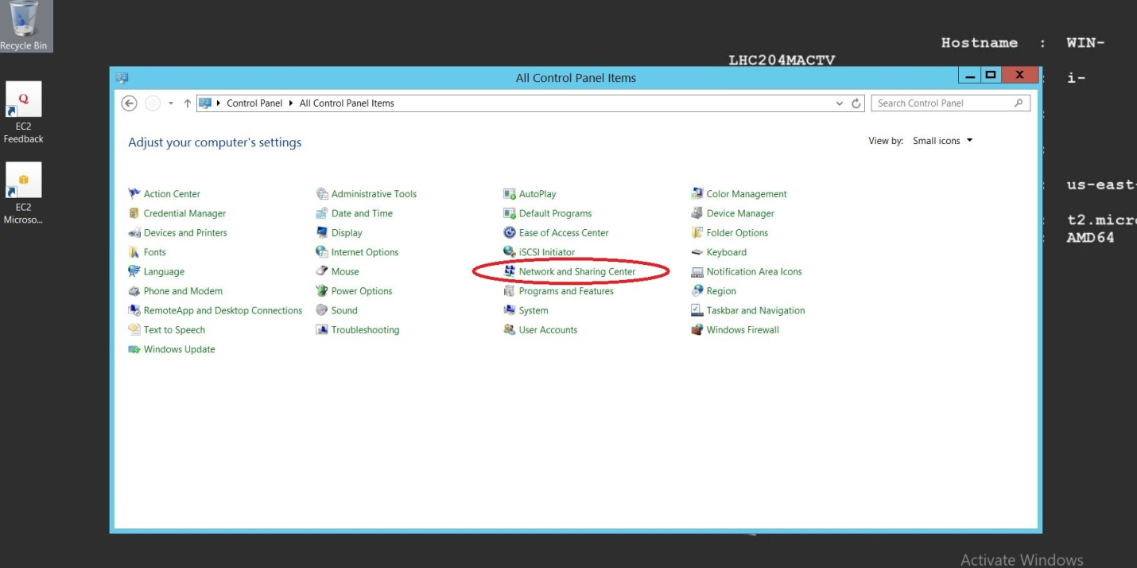

Click on Network and Sharing Center

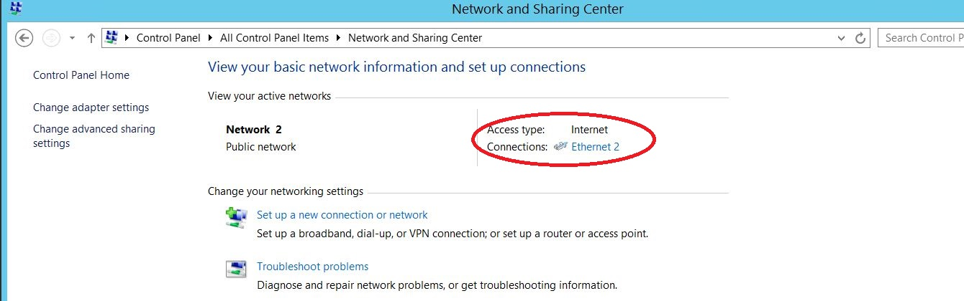

Click on Etherner2

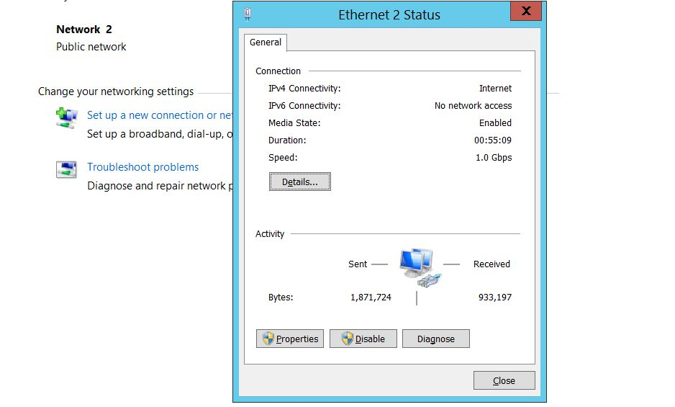

Click on Properties

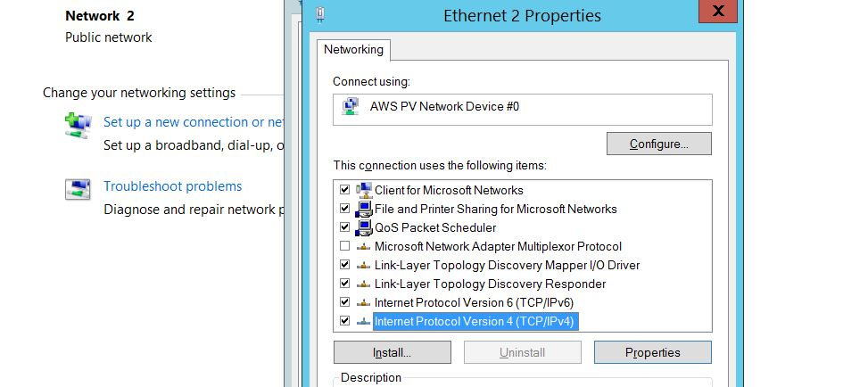

Select Internet Protocol Version 4(TCP/IPv4) and then click on Properties

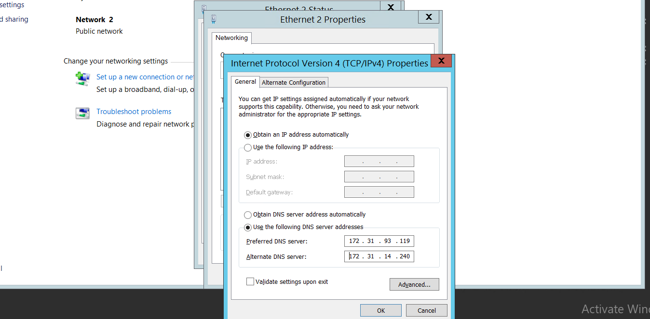

Give DNS Server addresses which we get from our directory and then click on ok

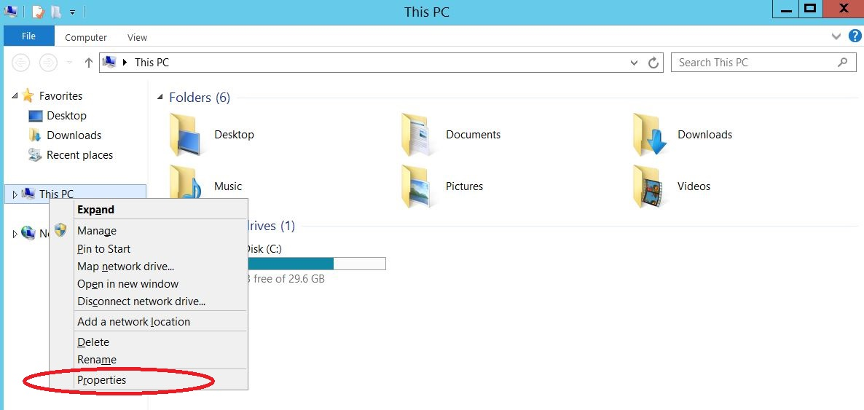

Goto system properties and check Workgroup

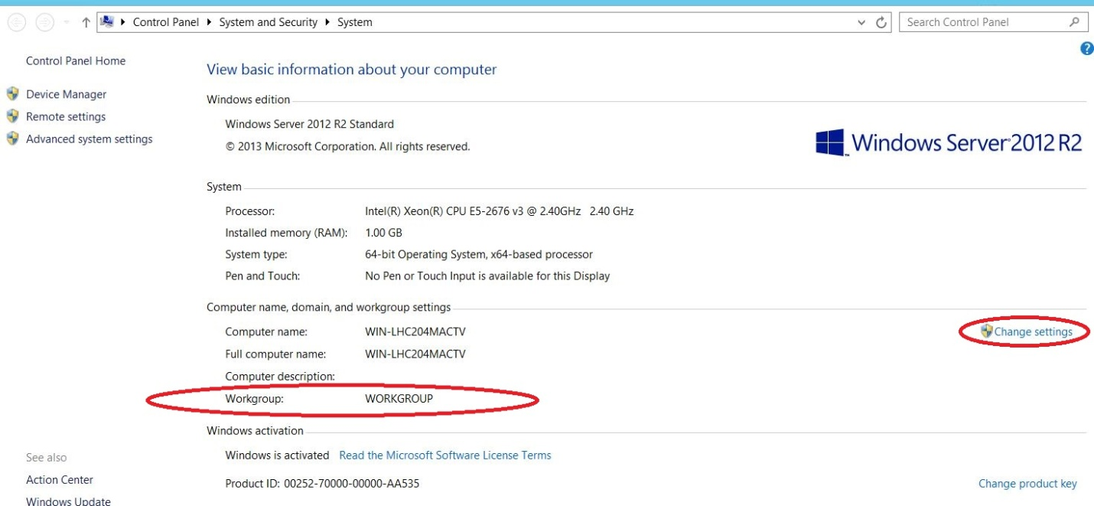

Click on change settings

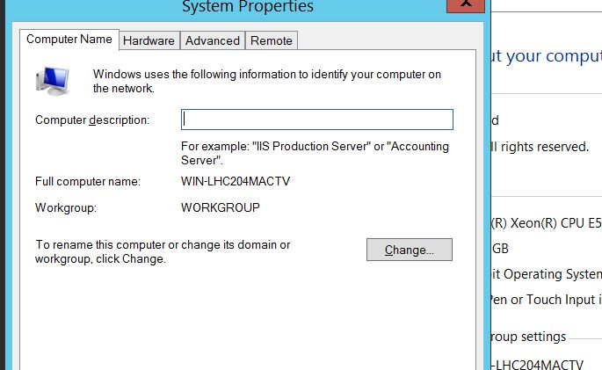

Click on Change

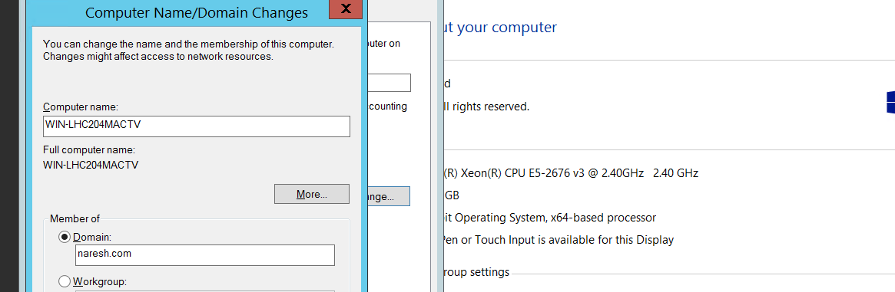

Give Domain Name as Directory DNS Name

Click on OK

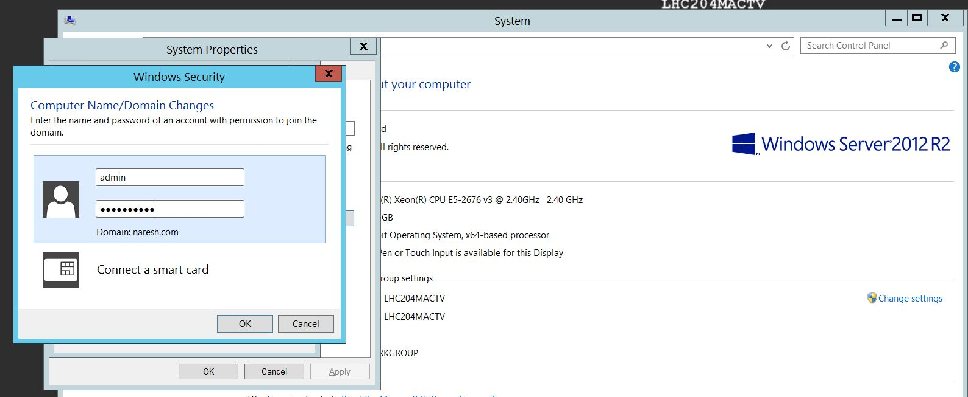

Give User Name as **admin** and Password **which we given while creation of Directory**

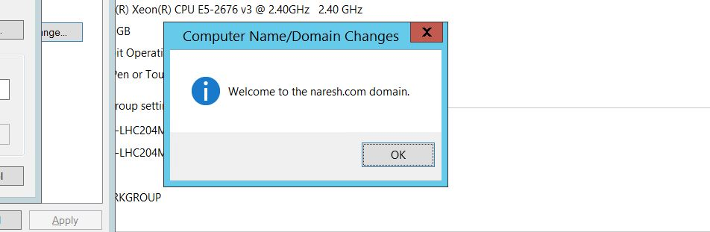

Click on **OK**

And Restart our workspace and check Workgroup name(It will be changed with our Directory DNS name) also reboot our EC2 Instance.

Again connect to our workspace, but at this time connect with Admin

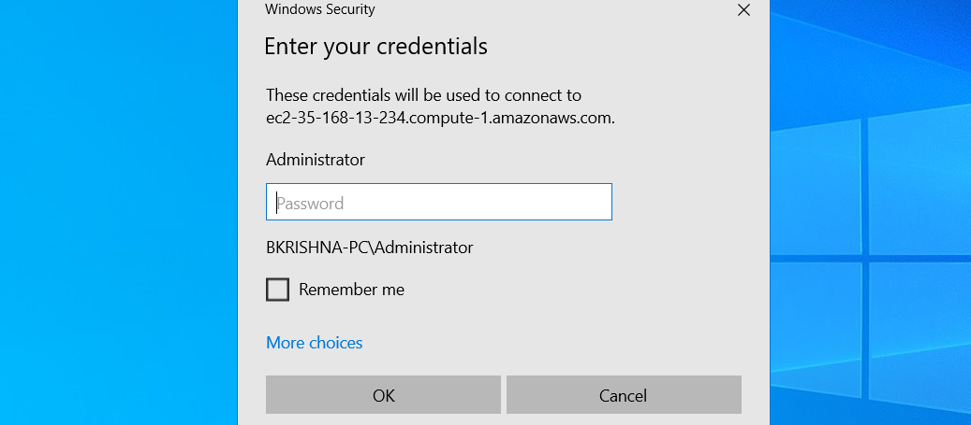

Click on More choices

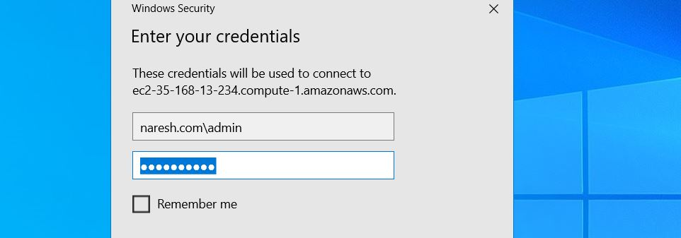

Give User name as : <Directory-DNS-Name\admin>

Check Domain changed or not

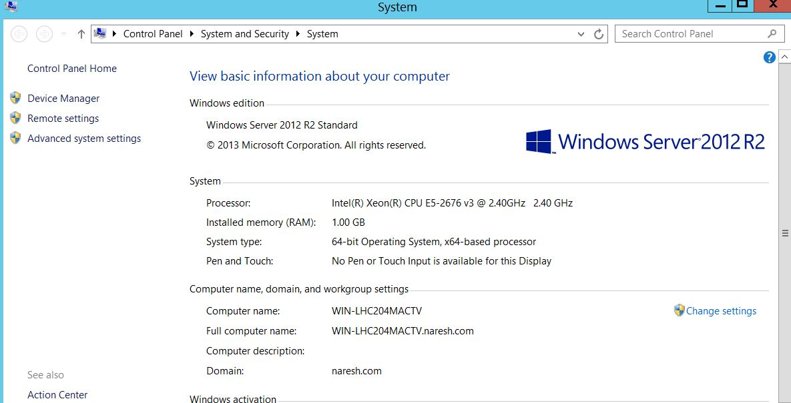

**Install Active Directory and Directory Services:**

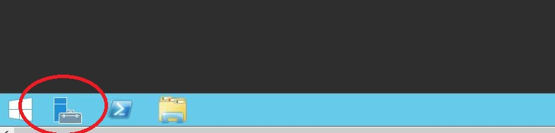

Select Service Manager

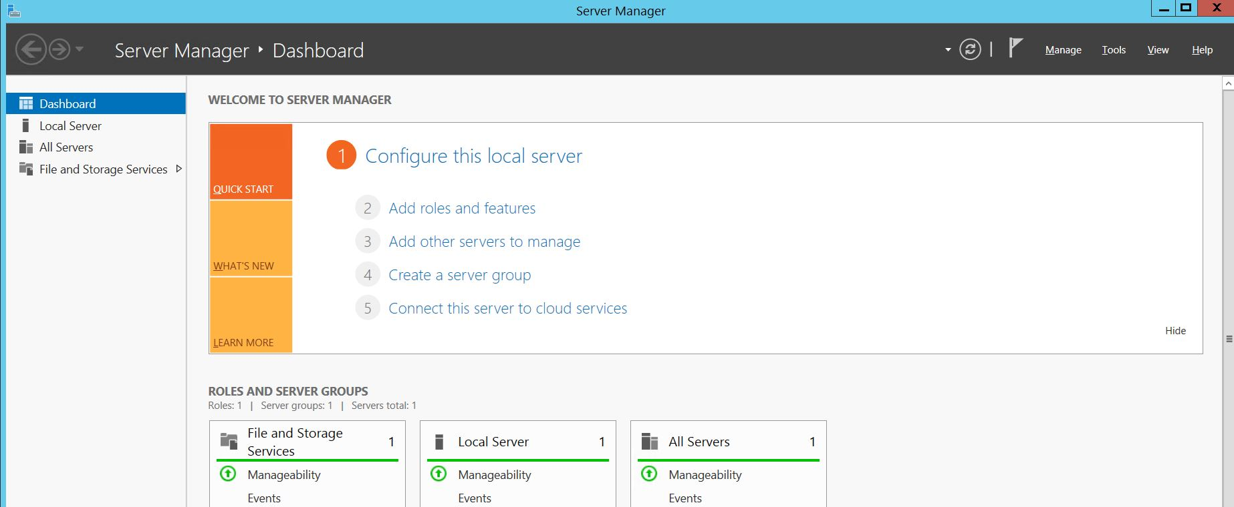

Select Add roles and features

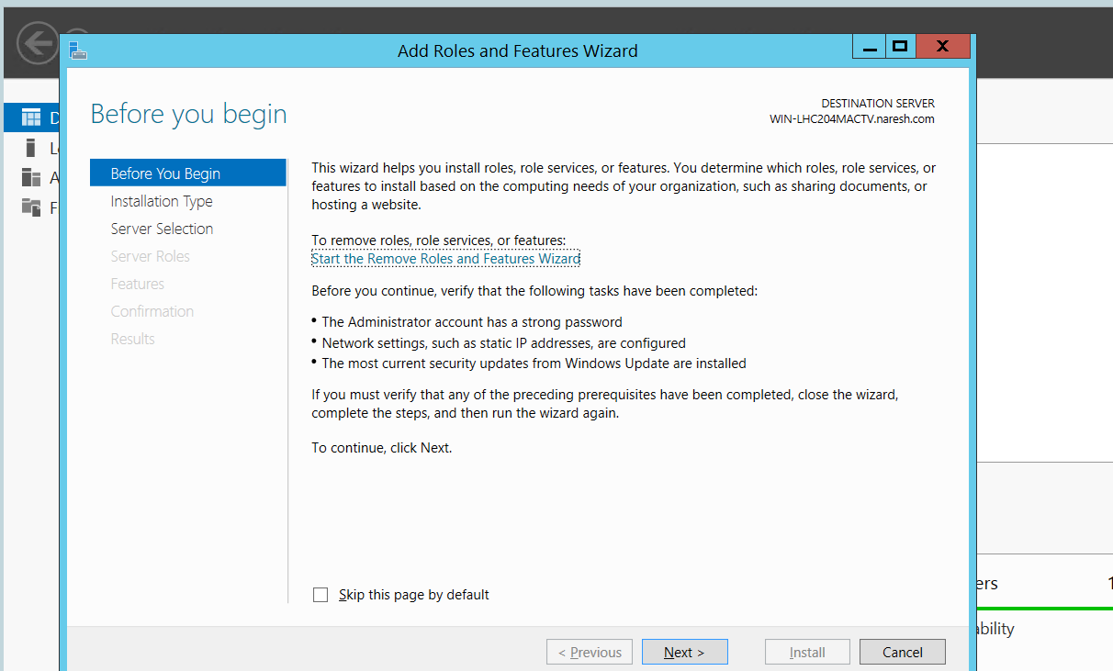

Click on Next

Select Role based or Feature based Installation and then click on Next

Not selecting any role and click on Next

Add Active Directory related services

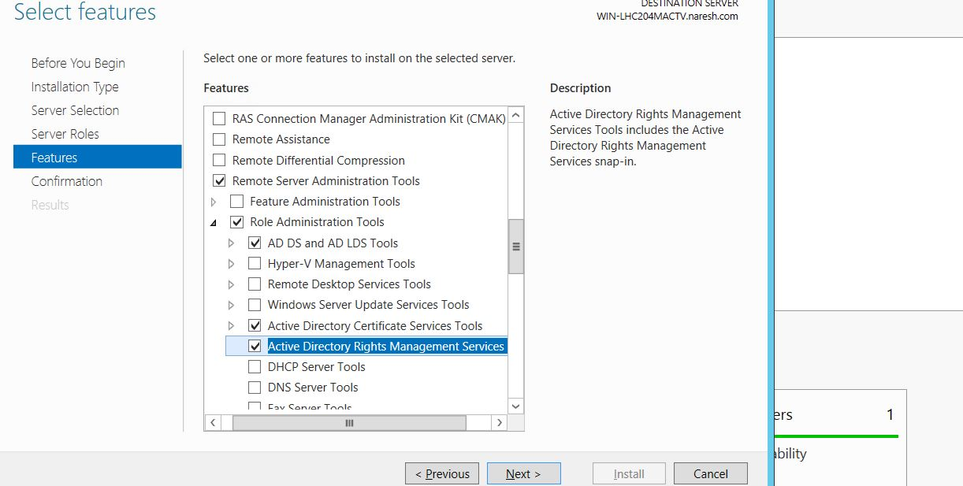

Click on Next and click on Install

Once Installation Done click on Start button and check Active Directory Related services Installed or not

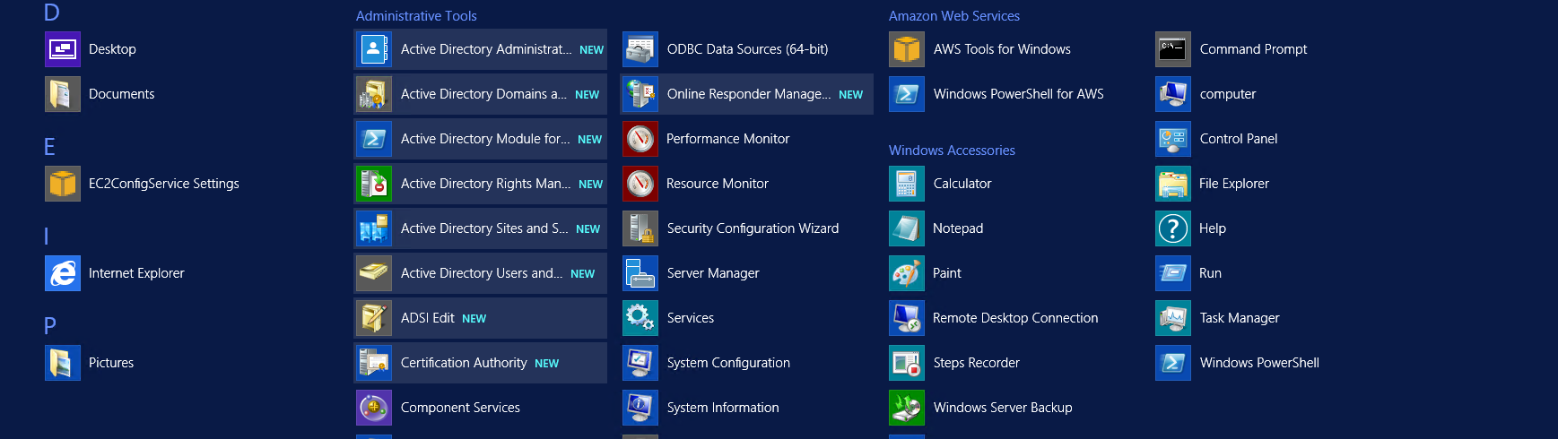

To add User:

Click on Active Directory Users and Computers

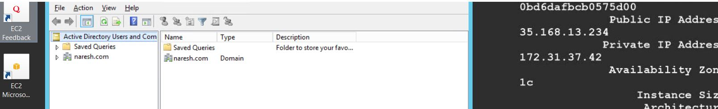

Click on naresh.com 🡪 naresh 🡪 Users

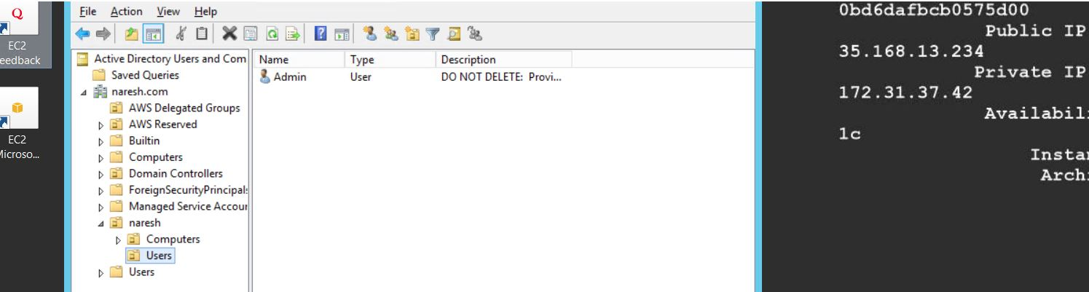

Click on Right click 🡪 New 🡪 User

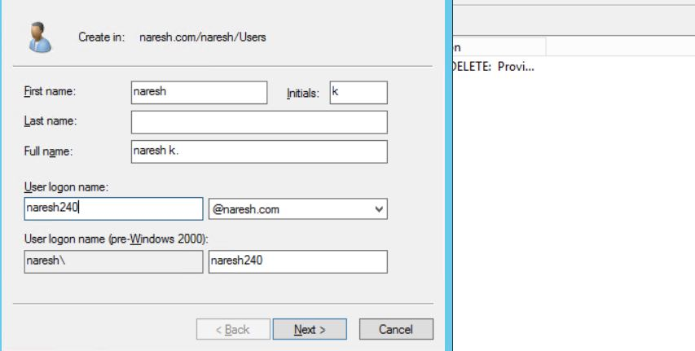

Fill blanks and Click on Next

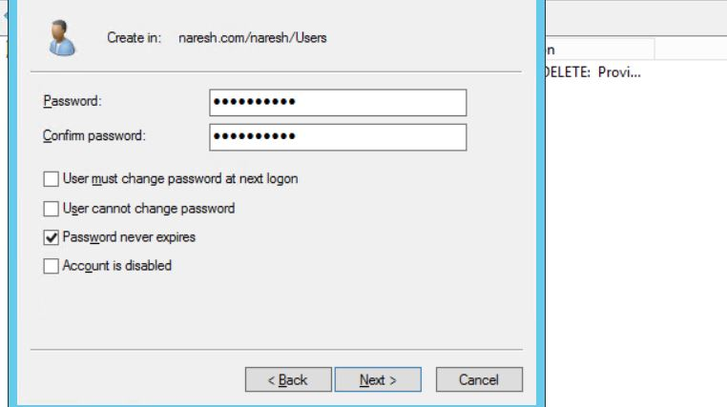

Set Password and Click on Next and then click on Finish

Check whether user created or not

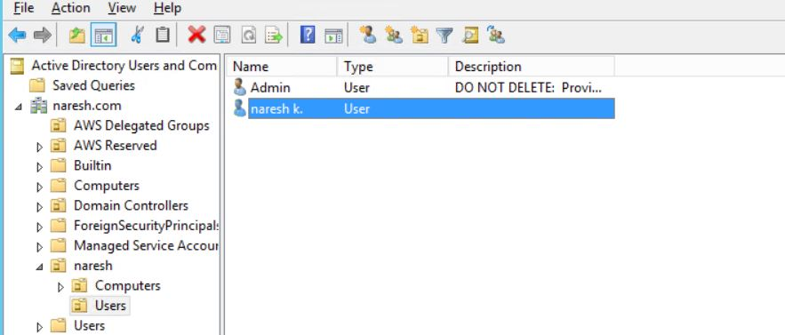

Now you can connect with this user on any of the machine and that machine to be added to AD